**User Manual**

The Operation of this manual is customers and admin how to going to be used in this document. For customer we are showing separate web pages and for admin am showing different pages.

**User Manual Document Format**

**Introduction**

Customer can register first after register he can login. Here for bluewave contain the student, employee’s passengers with disability and senior citizens peoples can use this system.

**Hardware Configuration**

I was installed this web site into my machine, the Hardware configuration am writing fallows the following are the minimum hardware compatibility is required.

* System : Pentium IV 2.4 GHz.
* Hard Disk : 320 GB.
* Monitor : 15 VGA Colour.
* Mouse : Logitech.
* Ram : 512 Mb.

**SOFTWARE REQUIREMENTS:**

* Operating system : Windows 7.
* Coding Language : JAVA/J2EE
* IDE : Netbeans 7.2
* Database : MYSQL
* Web Server : Tomcat 7.0
* WEB Browser : Google Chrome
* Documentation : Rational Rose

Screens Dumps

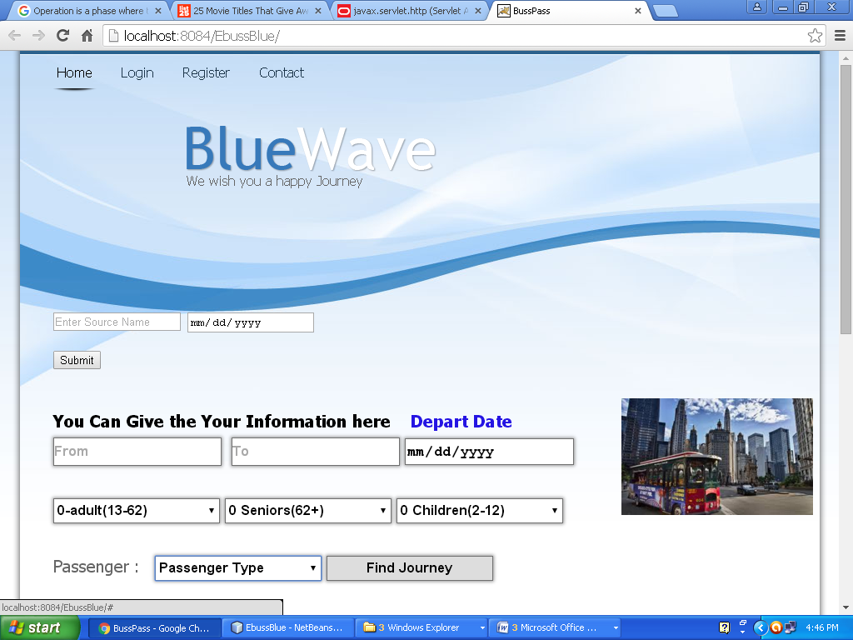

Homepage of the Bluewave

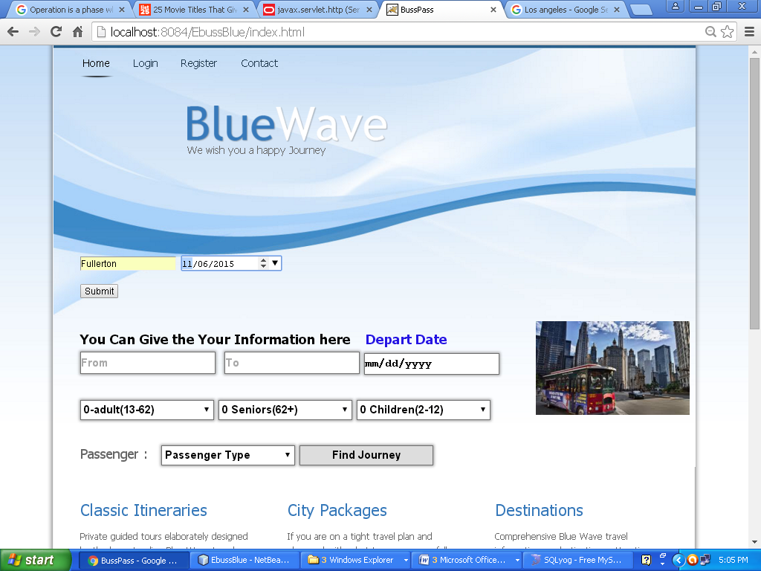

Finding Available busses or trains from the given Stop name

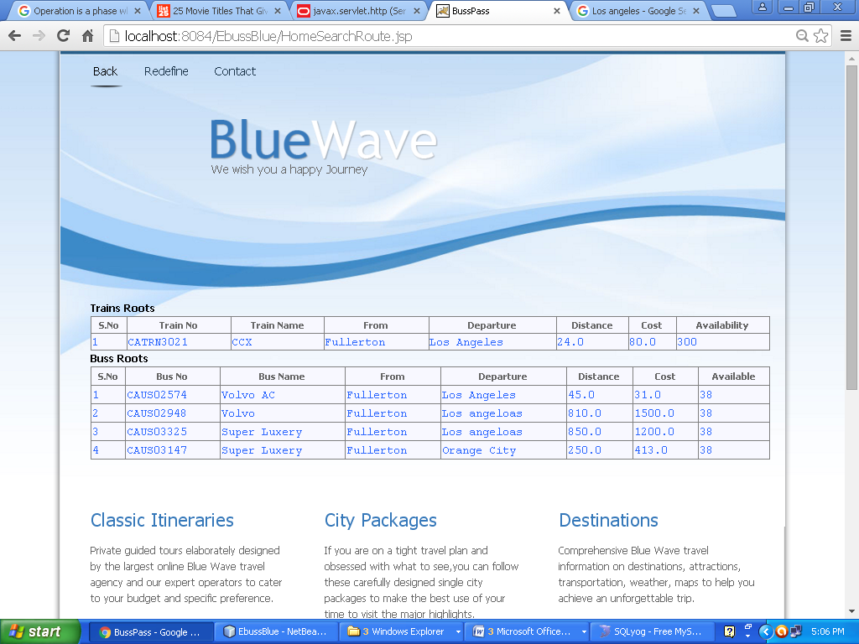

View The bus and Trains and fare

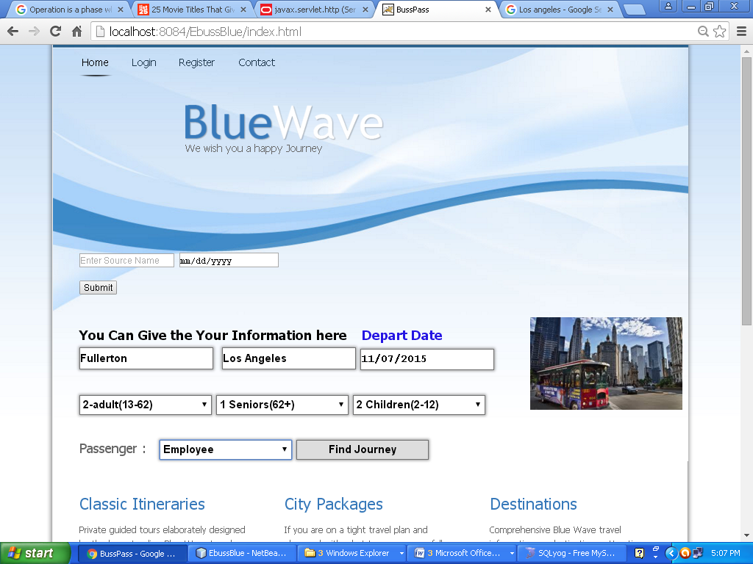

Planning Journey without Login

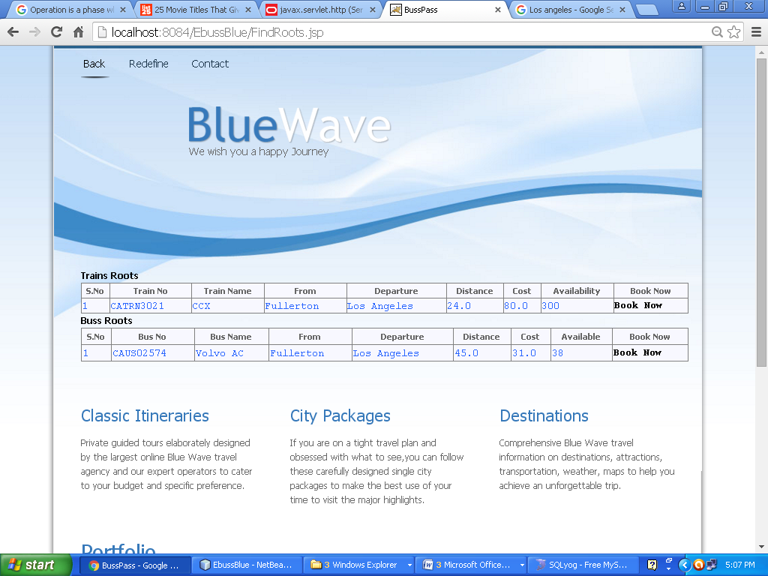

Showing available data

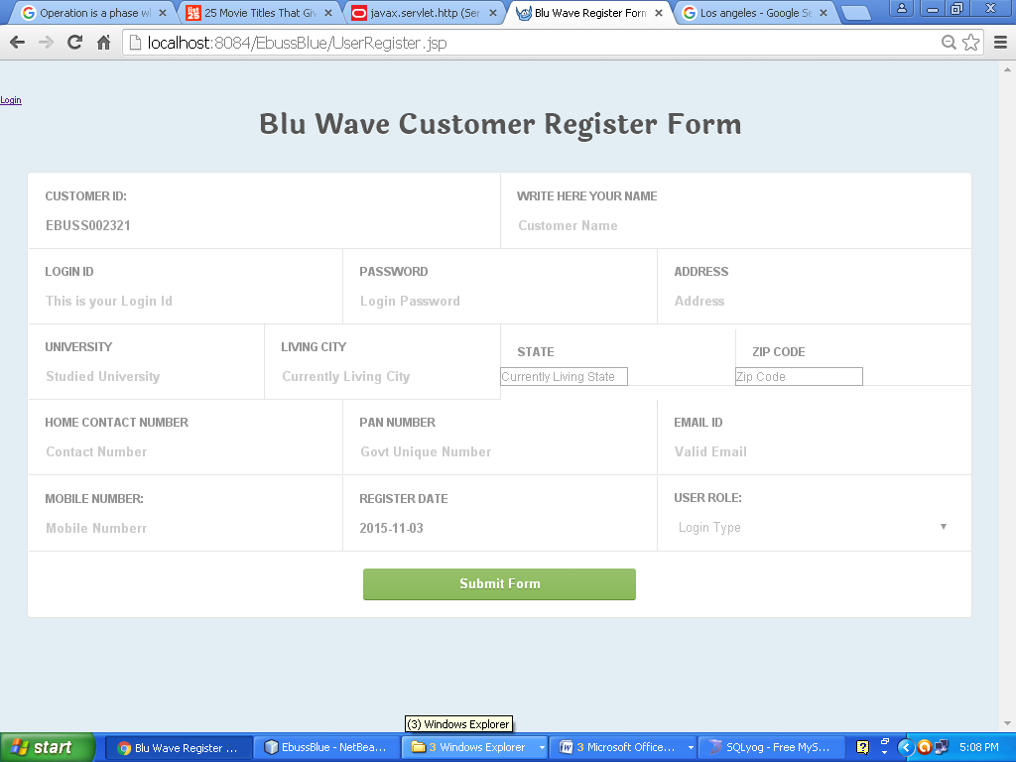

Registration Form of the Customer

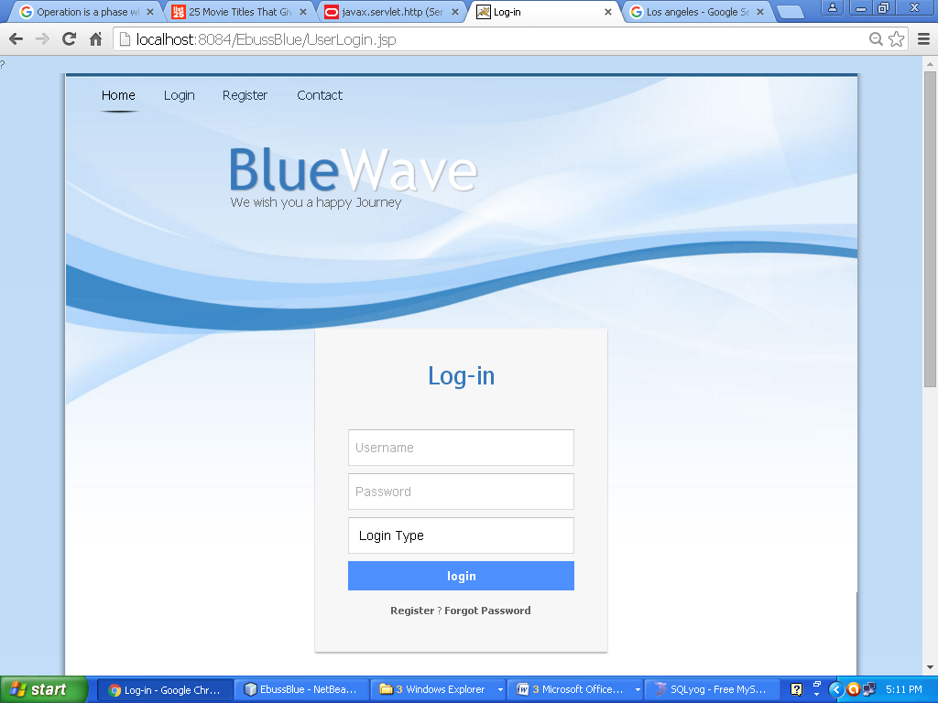

Customer Login page

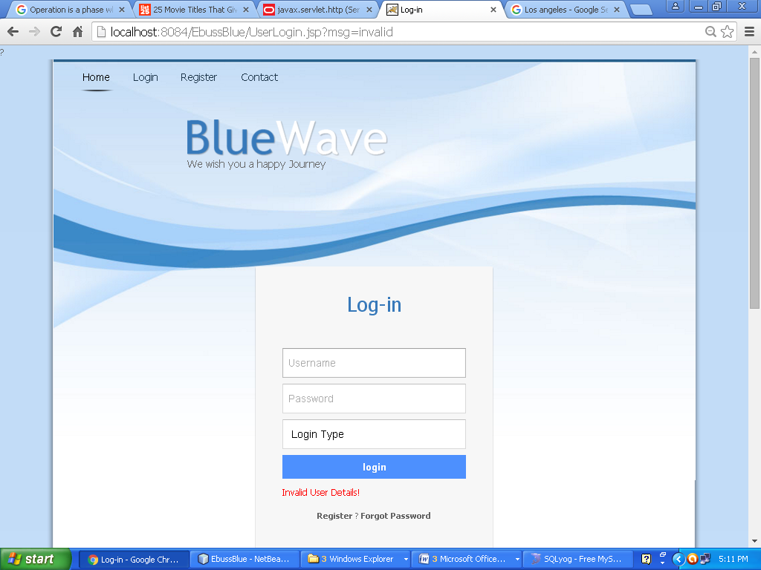

Login failed

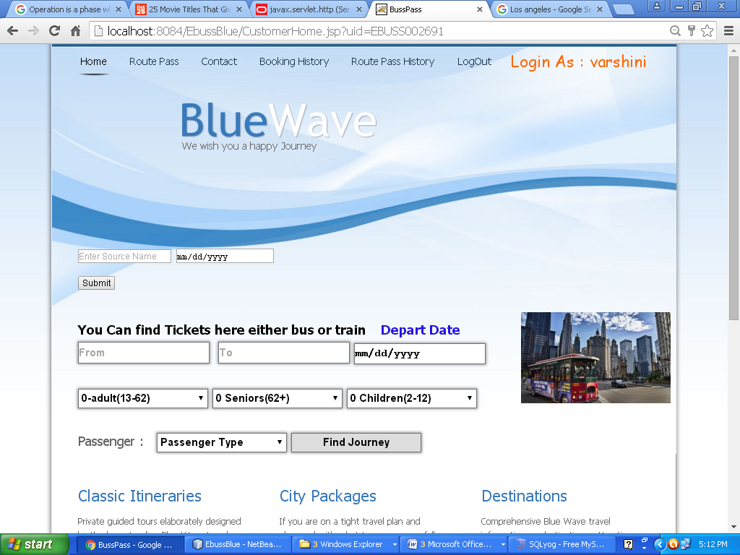

Customer Home Page

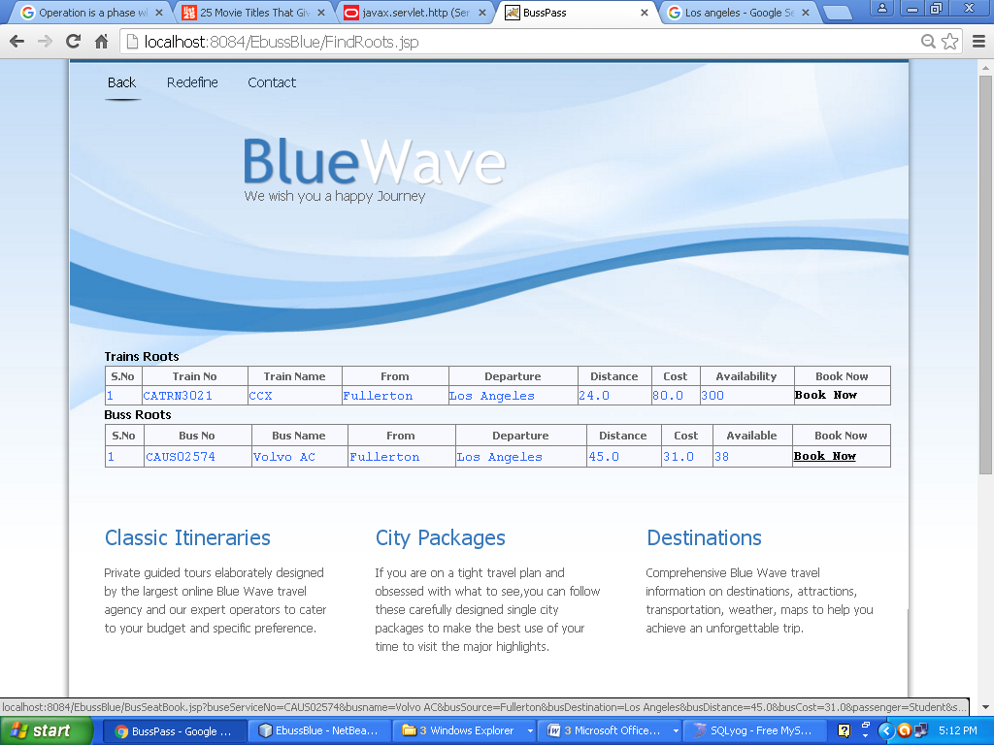

Logged Customer Book

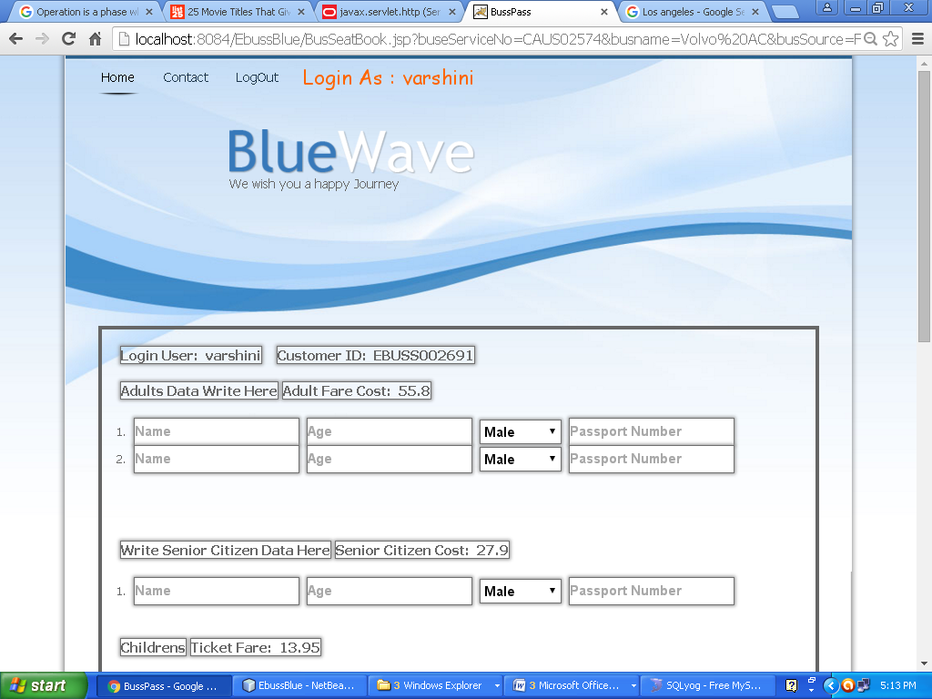

Filling the Traveling Persons Names

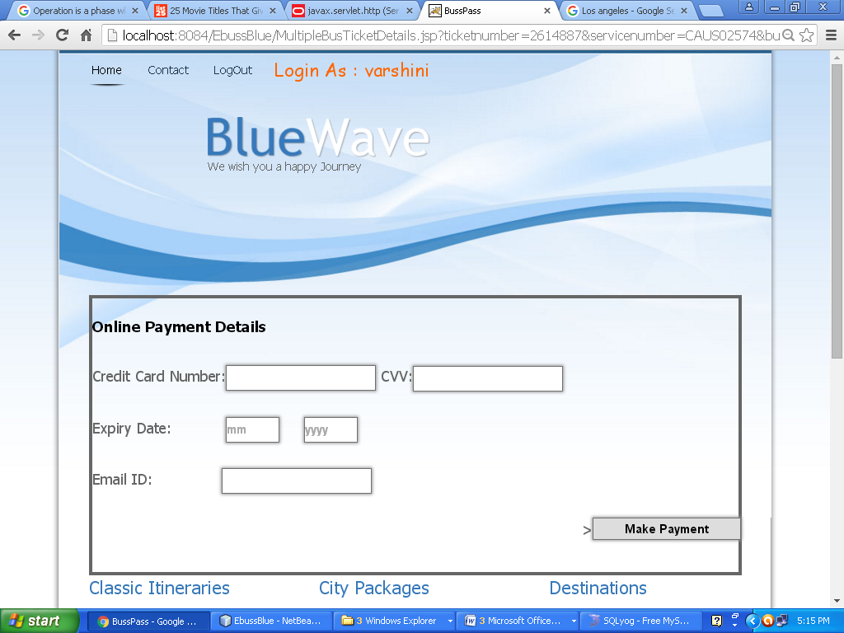

Payment Gateway

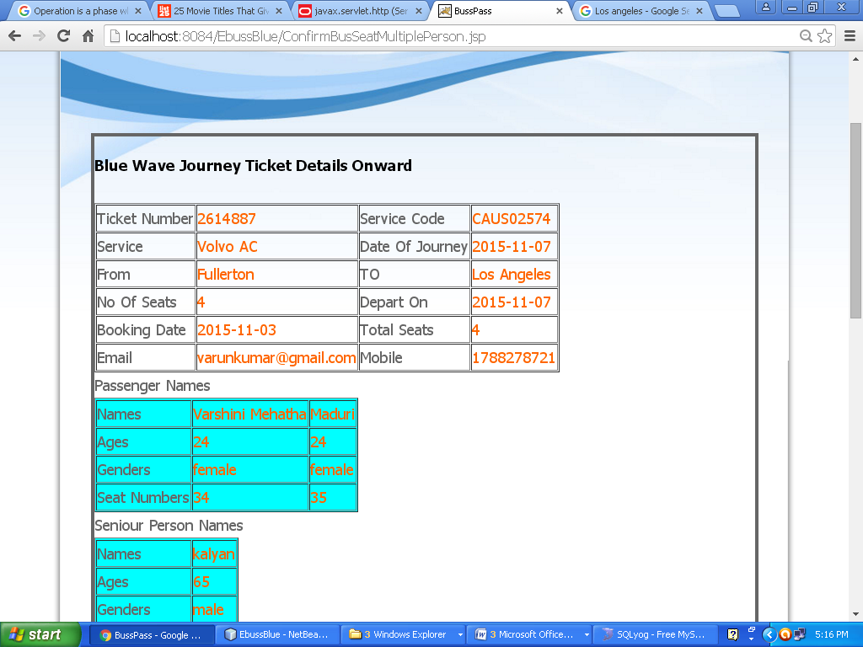

Final Ticket For The Customer

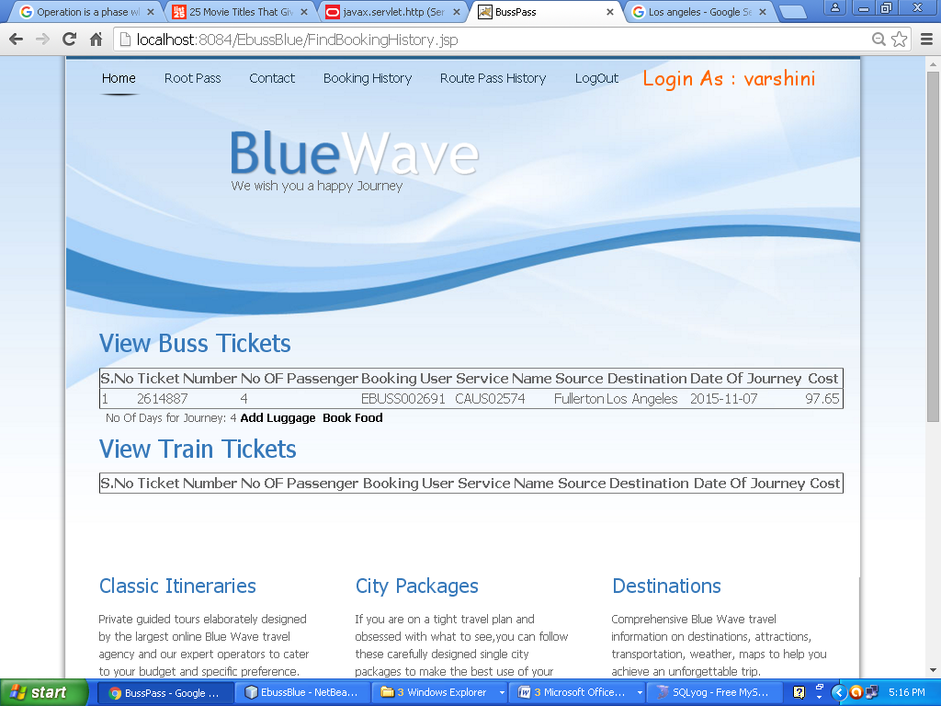

Adding Luggage

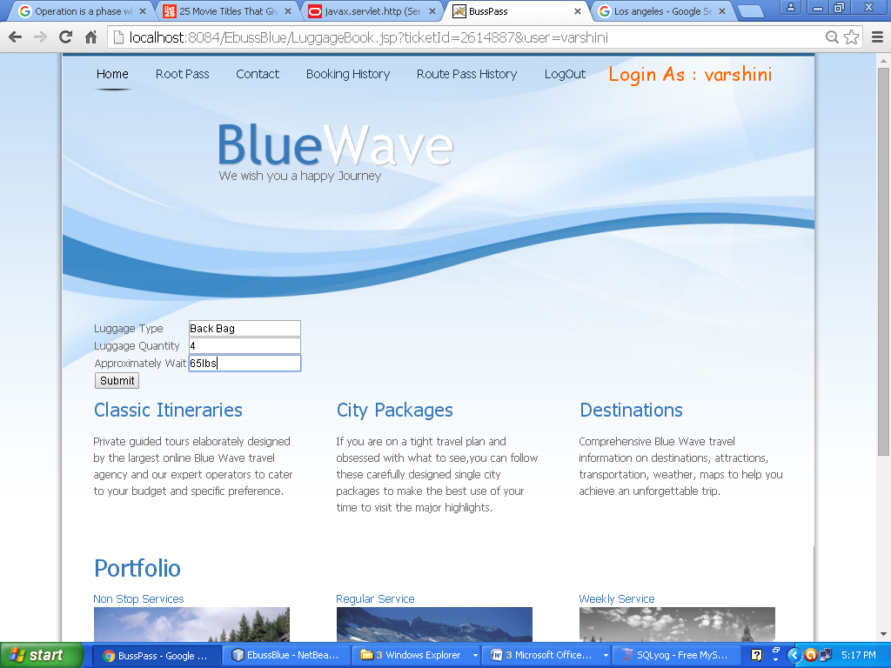

Adding Luggage Info

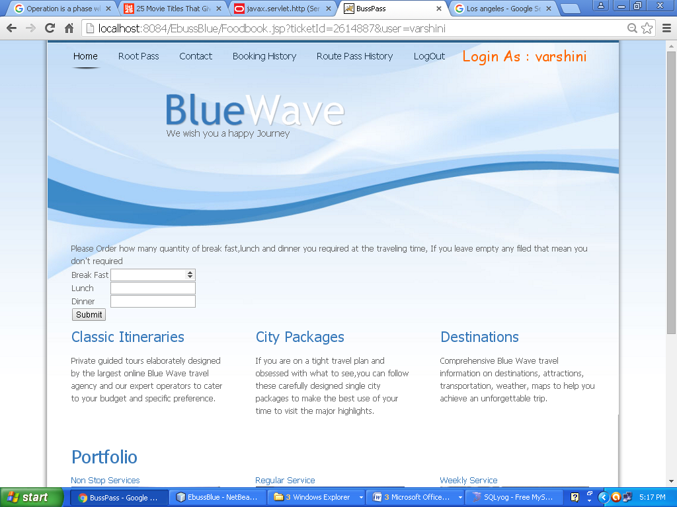

Adding Food Data

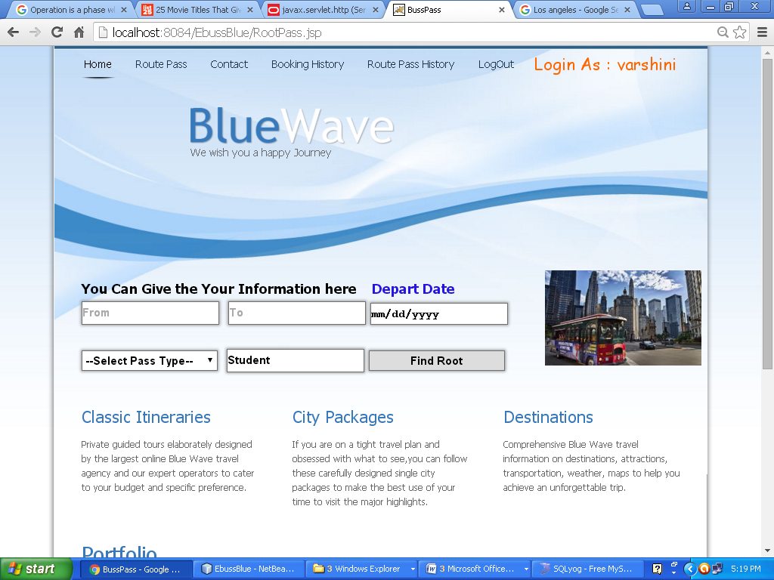

Finding Route Pass

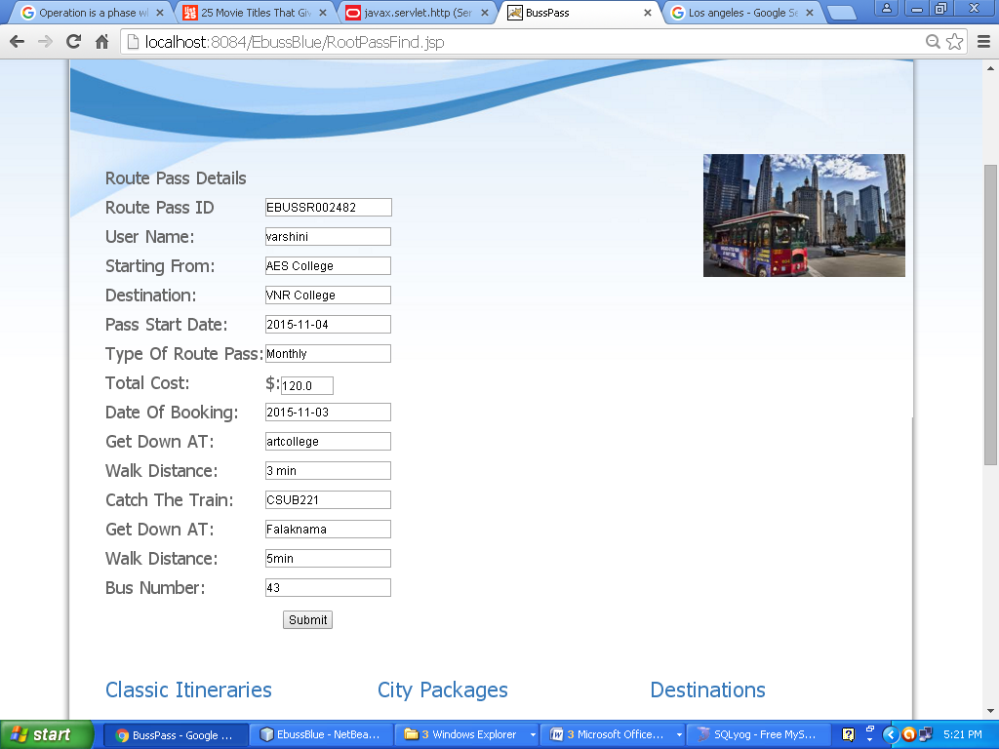

Routes pass for the customer

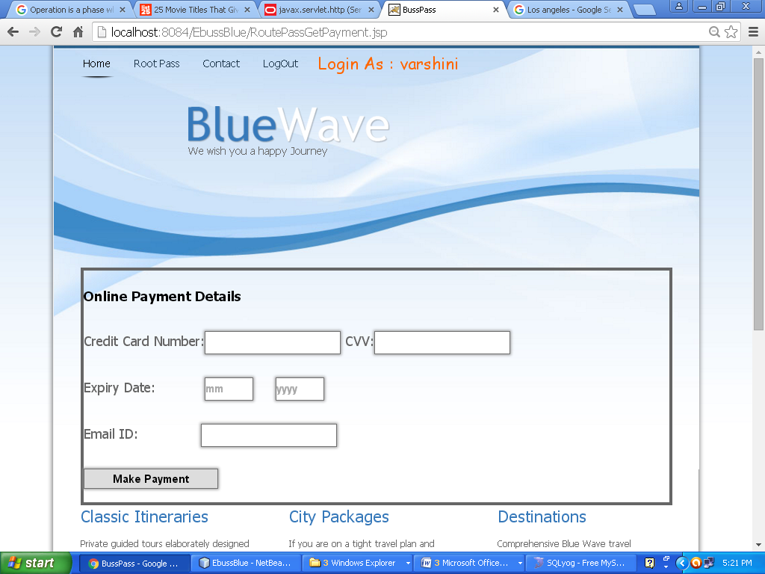

Payment gateway for Customer

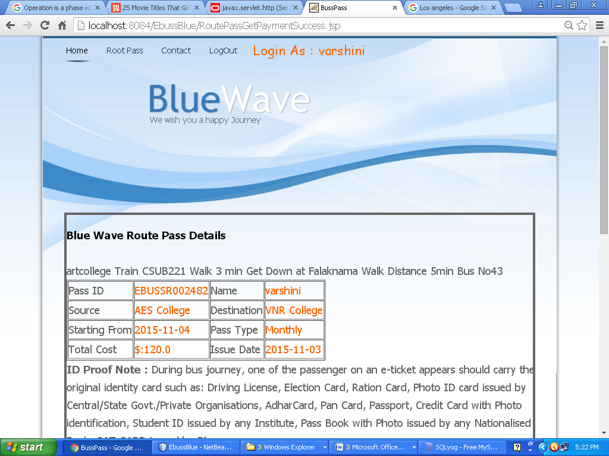

Route Pass final ID

Here Customer has to remember the Pass ID

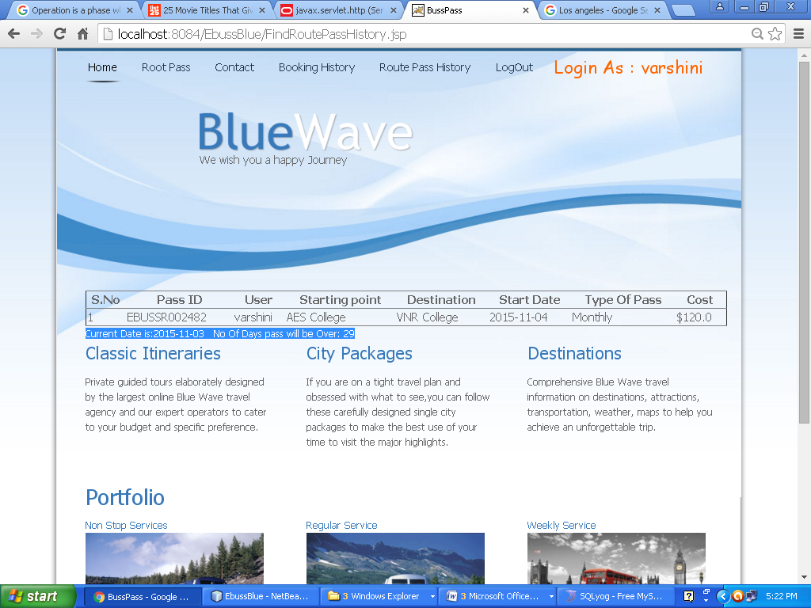

Route Pass Expires in Some days

Admin Login Page

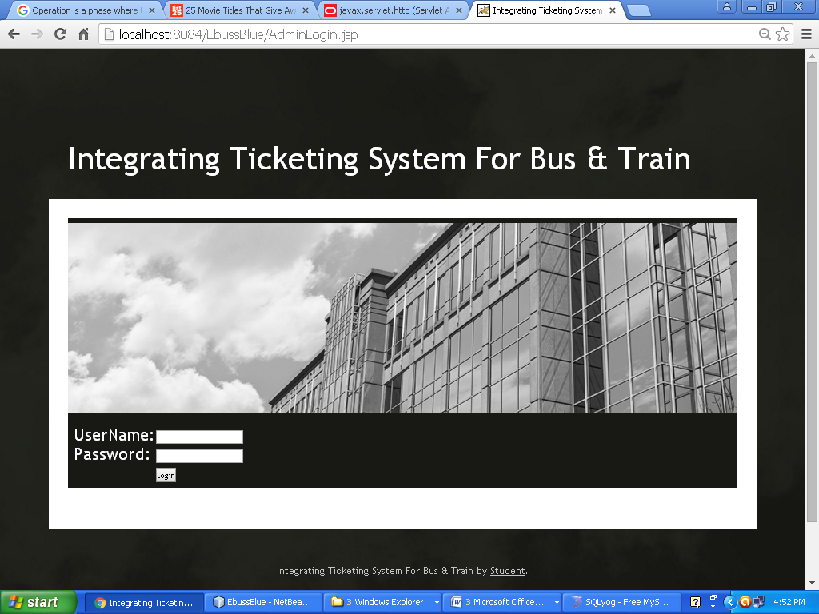

Admin Login page

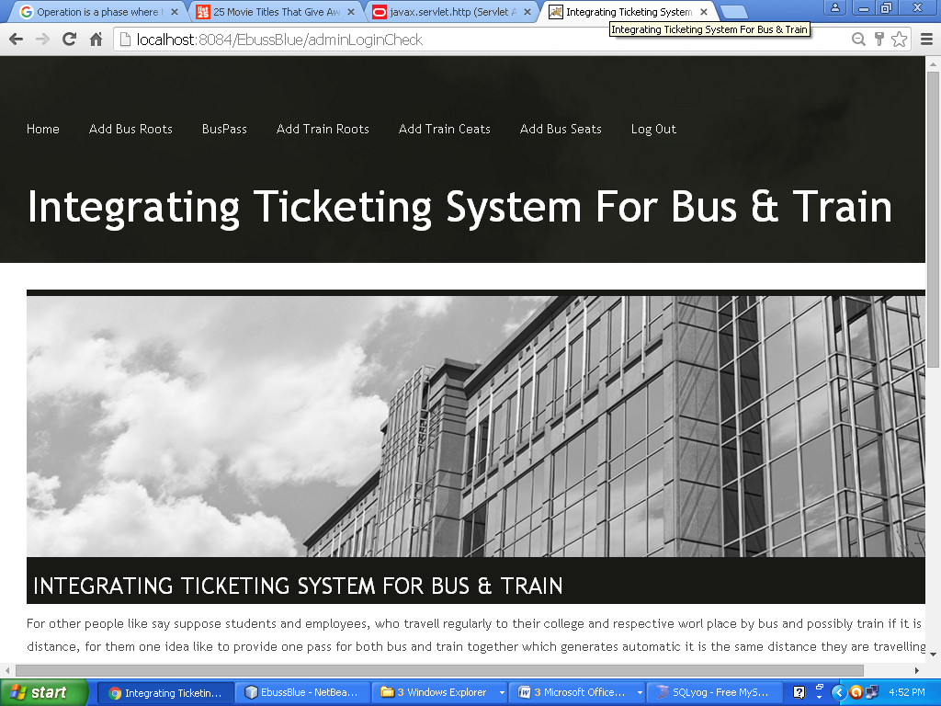

Admin Homepage

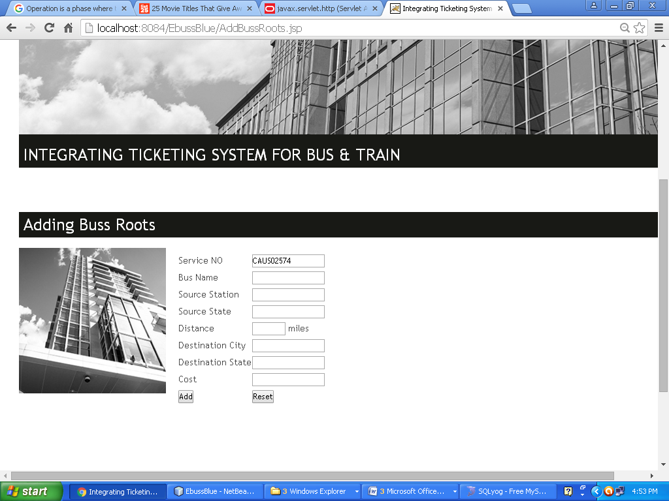

Adding Bus route by Admin

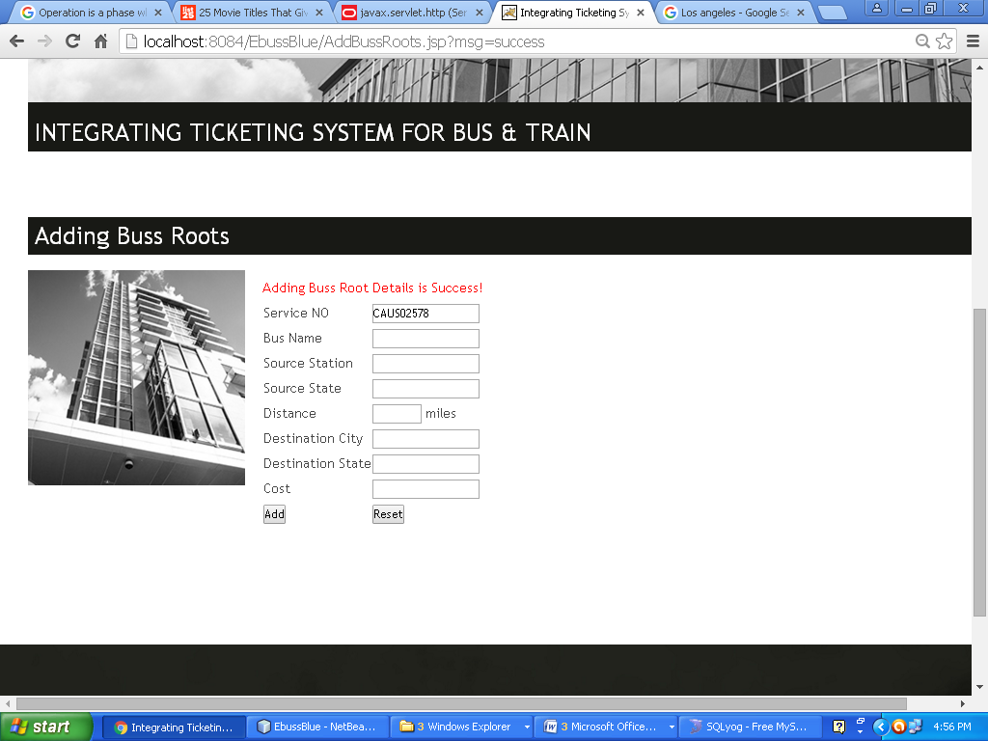

Buss Route Added By Admin Success

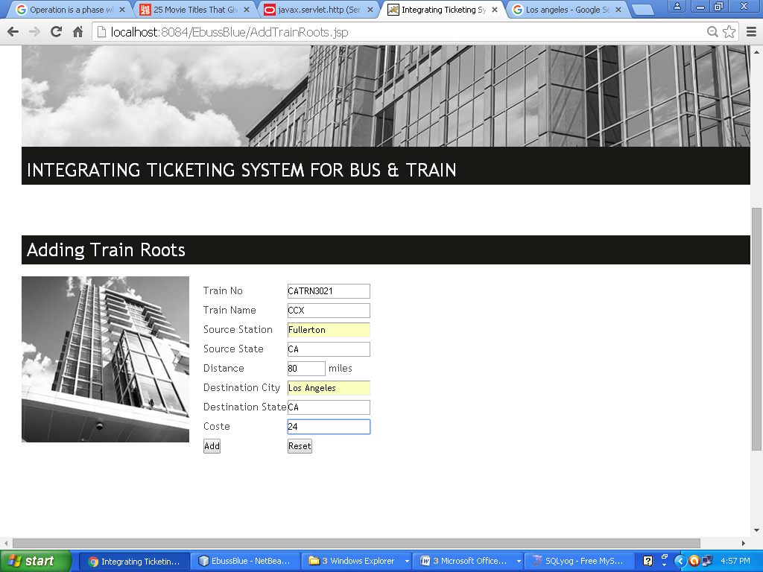

Train Route Adding by Admin

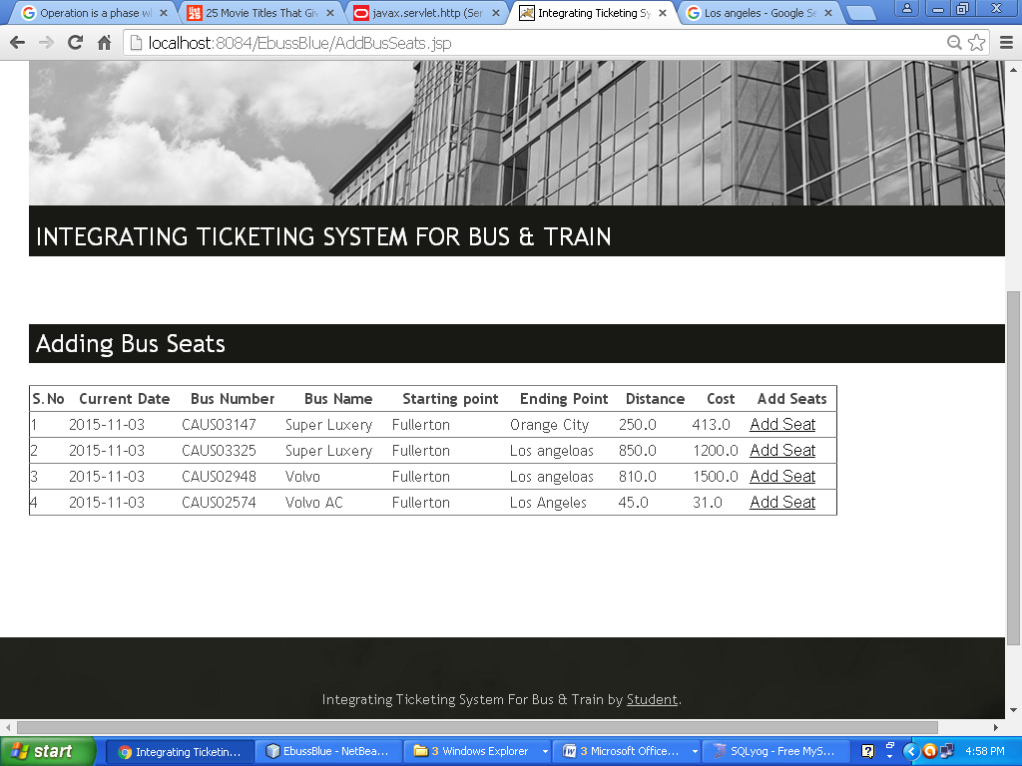

Add for Seats in bus here Admin can click the add seats to the particular bus route in that buss initially the 38 seats will be added for next 60 days.

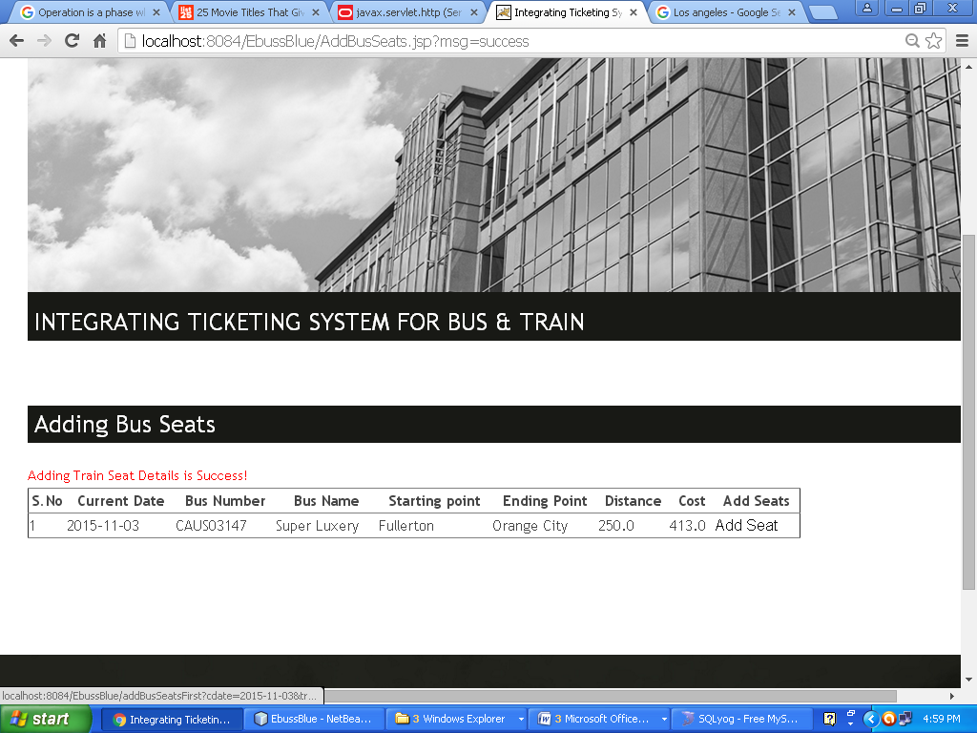

Added Bus Seat Success

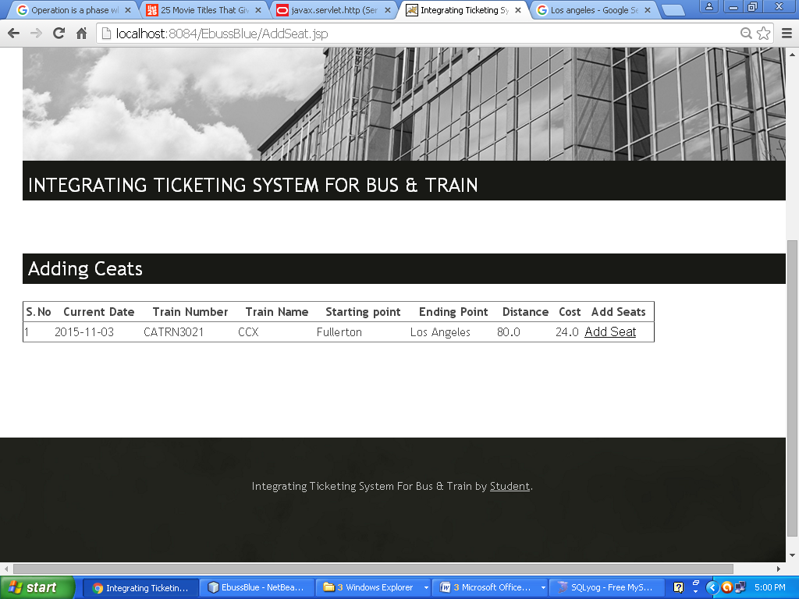

Adding Train Seats

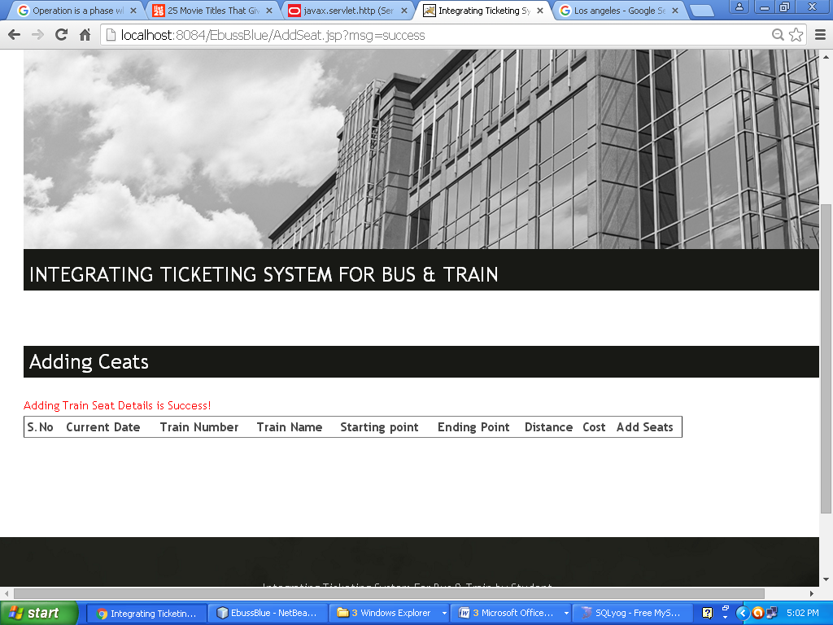

Adding Train Seat Success

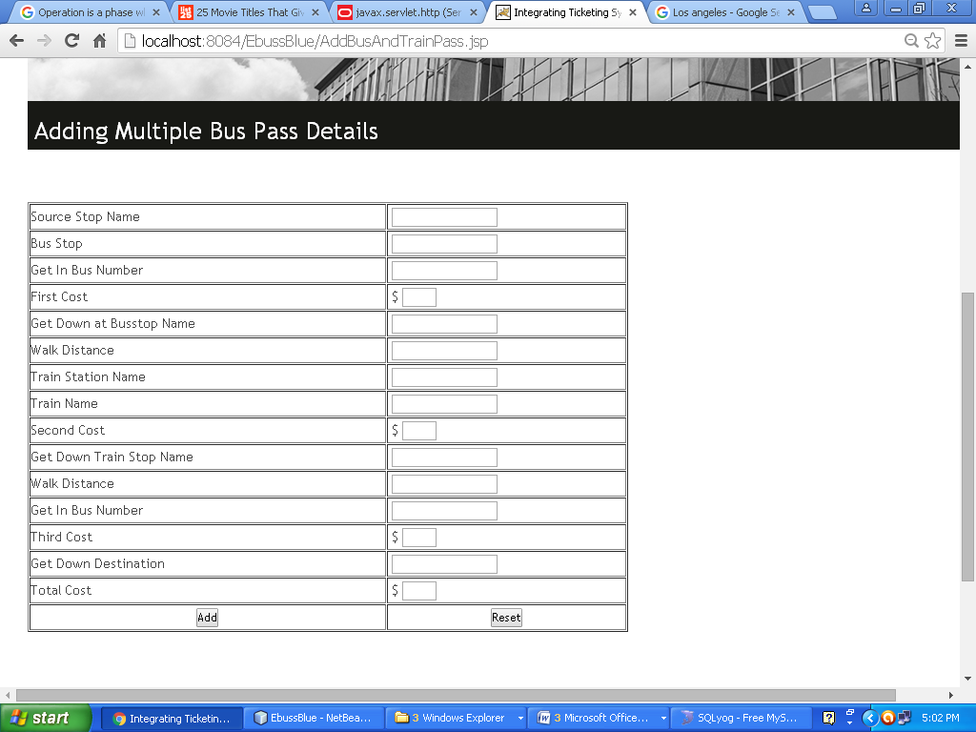

Adding Route pass data

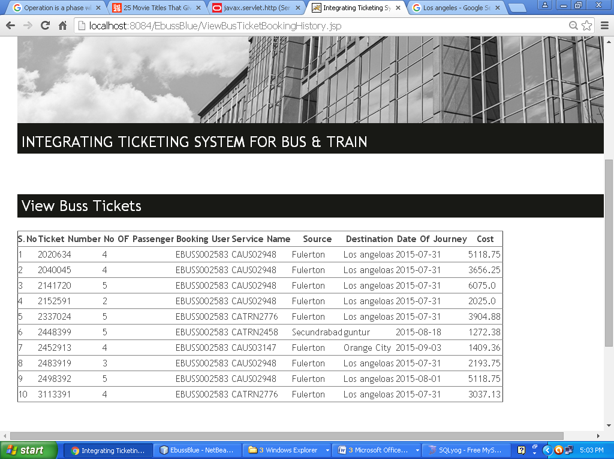View Train Tickets by admin

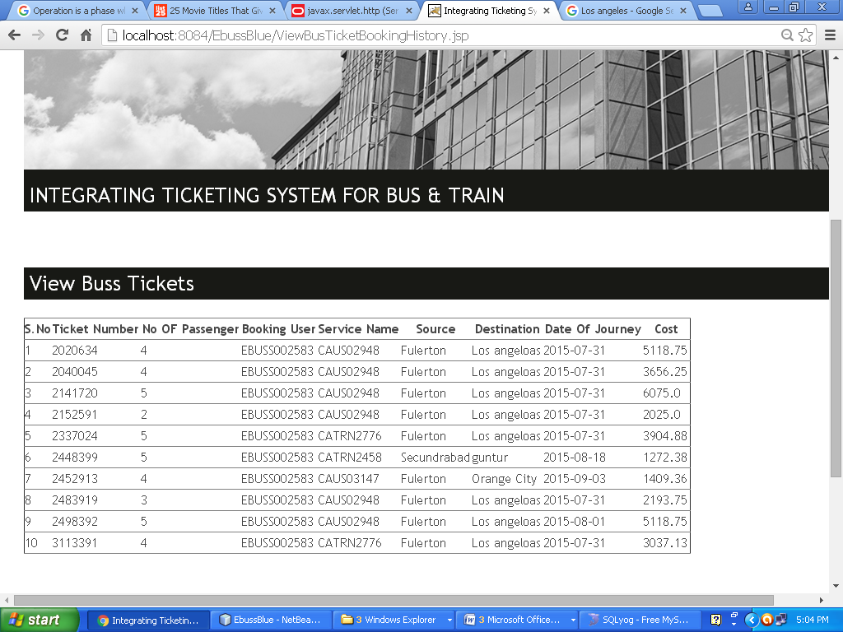View Bus Tickets by admin

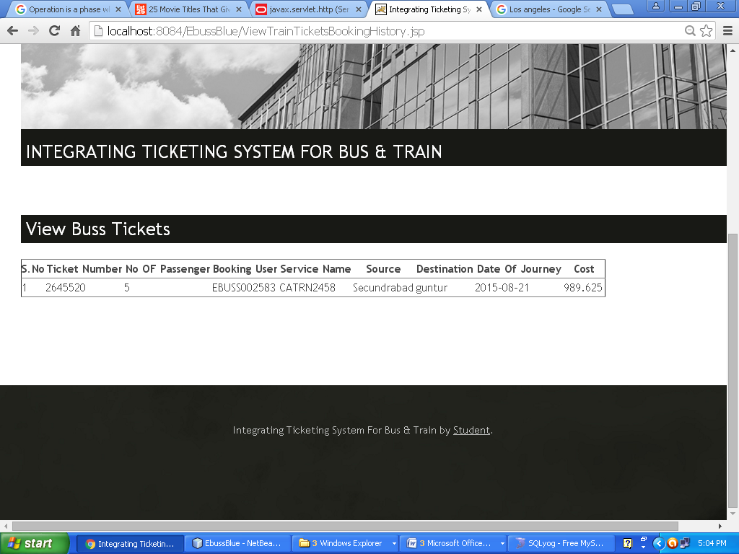

View Train Tickets

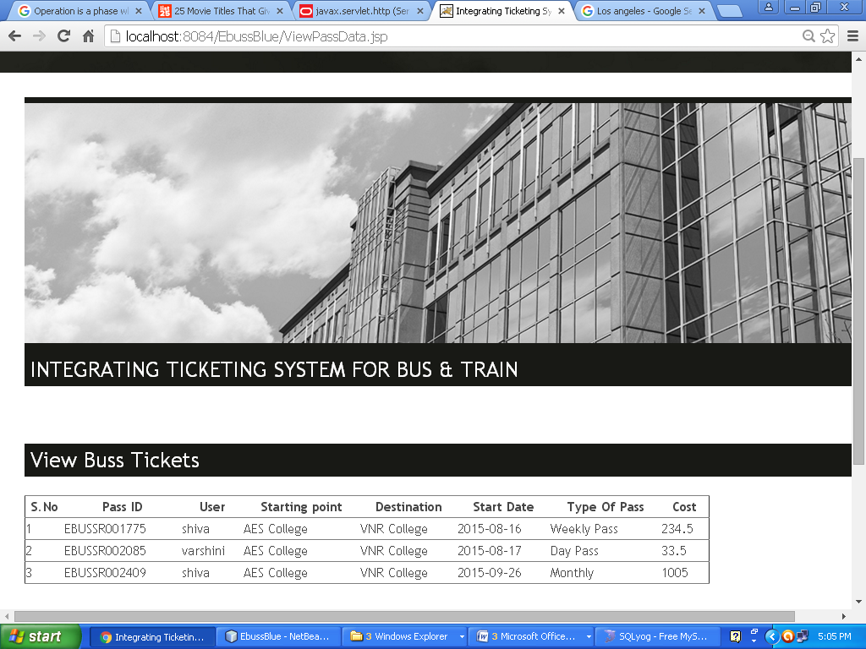

View Route pass by Admin